**PHARMACY**

**MANAGEMENT**

**BJS**

Bharatiya jain sanghatana

**A**

**Project Report On**

**“PHARMACY MANAGEMENT”**

**Submitted to**

**SAVITRIBAI PHULE UNIVERSITY**

**In partial fulfilment of the Requirement of** Bachelor of Business Administration (Computer Application) (Semester – VI)

**Submitted By**

**SAMADHAN BABAR & SAURABH GAIKWAD**

**Under the guidance of**

Prof. Mr.H.P.Jagtap

Prof. Mrs. B. Kulkarni

Prof. Mrs. Satav SV

**BHARATIYA JAIN SANGHATANA’S**

**Arts, Science & Commerce College**

**DEPARTMENT OF B.B.A(C.A) CERTIFICATE**

**This is to certify that Mr. Samadhan Uttam Babar &**

**Mr.Saurabh Gaikwad of class B.B.A(C.A) Sem VI have**

**Completed the project work on**

“**PHARMACY MANAGEMENT.**”

**Under my guidance & supervision in a satisfactory manner for the Practical fulfilment of BBA CA (VI) examination for the academic year 2021-2022.**

**Mr. Balwant B.Landage Major.Dr.Ashok Giri**

**(Incharge) (Principal of college)**

**Project Guide Internal Examiner External Examiner**

**Mr. H.P. Jagtap**

**Date: Place:**

|  |  |  |  |
| --- | --- | --- | --- |
| INDEX | | | |
|  | **SR no** | **Description** | **Page No** |
| **1** | **Introduction**   1. **Introduction** 2. **Acknowledgement** |  |
| **2** | **Existing System**   1. **Existing System** 2. **Advantages** 3. **Disadvantage** 4. **Fact Finding Technique** |  |
| **3** | **Proposed System**   1. **Hardware and Software Specification** 2. **Feasibility Study** 3. **Proposed System** 4. **Objectives** 5. **Scope of System** |  |
| **4** | **System Analysis**   1. **ERD** 2. **Context Level DFD** 3. **First Level DFD** 4. **Second Level DFD** 5. **Use Case Diagram** 6. **Class Diagram** 7. **Activity Diagram** |  |
|  | | |
|  | | | |
|  |  | **8. Sequence Diagram** |  |
| **5** | **System Design**   1. **Data dictionary** 2. **User interface** 3. **Inpute Design System** 4. **Output design report** |  |
| **6** | **Future Enhancement** |  |
| **7** | **Biblography** |  |
|  | | |

**INTRODUCTION**

* It is a small software package which is helpful in the areas of shop.

* The activities like customer entry , dealer management, employee managing, the data summary, etc are included.

* All the data are saved automatically in the defined place and are retrieve from there directly by using this software.

* In terms of security this software is totally secure as it doesn't give access to unauthorized user as the username and password facility is provided.

**Acknowledgement**

I would like to express my gratitude and sincere regards to the following people to whom I am grateful for their support and help without which I would not have been able to do this project entitled **“MASTEK STG RESOURCE PORTAL”.**

My special thanks to **Guide**, **Mrs. Satav** whose cooperation and keen interest coupled with valuable suggestion helped me in the completion of the project.

Last but not least, I am thankful to all **Teaching and Non-Teaching staff** of the college, whose names has not been mentioned here but have directly or indirectly, helped me in the completion of this project.

**Existing System**

* Consumes more time and effort for updating
* Reports are not in attractive manner
* Efficiency and accuracy cannot be expected
* Quick and timely services are not provided
* Slow processing speed
* Readymade data retrieval is difficult

# ADVANTAGES

1. **User Friendly :**

The system has got much simplified screen which makes the system fast enhances quick and accurate data.

1. **Validations Check:**

The system has various validation checks and it also givesappropriate error message .

1. **Report Generation:**

The system can generate various reports giving dealer details, stock details, bill details, Purchase details etc.

1. **Easy to learn:**

This system is easy to understand, this mainly due to simplefunctionality.

**LIMITATION**

* This system is design to be standalone & does not work on network site

* It doesn’t online system i.e. it doesn’t provide online support

* The system is not platform independence

**Fact Finding Techniques:-**

* ***The technique which is used for collecting data about the requirement is called as fact finding technique.***
* ***It helps to gather the information in organized way so that no system details are left out, right problems are identical, repetitive work are four fact finding technique such as Interview, Questionnaires, Observation & Record review.***

But for our system we used the following techniques:

1. Interview:-

1. Structured
2. Unstructured 2.

Questionnaire

3. Observation

**1. Interview:-**

* The interview are structured and unstructured. In structured interview the pattern is fixed but in unstructured interview. We can ask any type of different question.
* So here we used the unstructured interview. We collected the more accurate and reliable

**i. Structured Interview:-**

* Structured interview involves question which are set out and followed thoroughly. Each candidate is presented with the same question and this ensures and this ensures that each respondent had the opportunity to respond to each question. **ii. Unstructured Interview:-**
* An unstructured interview is “an interview without any set formal but in which the interview may have some key question formulated in advance.”

• The whole system investigation has done bytaking of Cold-drink shop manager, by asking him about

* Manual Process of each work.
* By discussing their problem deeply.
* By asking them about requirement about the system.
* By asking them their valuable suggestion.

**The following were asked:-**

* How does the system work?
* What is the important factors of Customer?
* What security measurement are maintained?
* How does your billing system work?
* How did you divide various sections on different levels?

## 2. Questionnaire:-

* We used this technique in the initial and final phase of our system. In initial phase we prepared the questionnaire to get some numerical data. We used to open ended questionnaire to know the current system.
* So we collect the required information for development of our system. Questionnaire may be used as a report to interview.

Questionnaire is useful for:-

* Gathering Numerical data.
* Getting relative simple opinion from a large number of people.
* Obtaining Collecting opinions.
* Standardized question format can produce more reliable data then other fact finding technique.
* We have use Questionnaire Fact Finding Technique for gathering Numerical data & collecting opinion.

## 4. Observation:-

* Observation is most useful when the analyst need to be actually how documents are handle. How process are carried out and whether specified steps are actually followed or not.
* Observation provides close view of the working of the real system. System analyst to get information, Which they can not be obtained by any fact finding technique. o Daily in doing work. o Information recalled the memory. o Skipped step.

o New Control needed.

**Proposed System**

* Proposed System The proposed system is computerized and has been developed using advance language therefore it gives more facilities than present system .

* It provides quick access to any data .

* In this system user have to enter the data only once and then it get linked with all files . This reduces the workload of user
* and it is also a time saving process .
* The information about any Subscriber can be easily retrieved .
* The system maintains all records easy .

# SYSTEM REQUIREMENT

**Hardware Requirement**

Processor : Intel core Duo 1.3 GHz or more

RAM : 800 MB or more

Hard-disk : 4GB or more

Monitor : 15” CRT, or LCD Monitor

Keyboard : Normal or Multimedia

Mouse : Compatible mouse

**Software Requirement**

Front End :Visual Studio 2008

Back End : MS Access Operation System : Windows 10

# FEASIBILIT STUDY

* It is necessary to determine whether the development of new program will be beneficial to the end user or not. This study examines the aspect like hardware and software requirements, costs and benefits and the time that are needed to develop a program.
* After doing the project ‘Mobile Shop management system’, study and analyzing all the existing or required functionalities of the system, the next task is to do the feasibility study for the project. All project are feasible- given unlimited resource and infinite time.
* Feasibility study includes of all the possible ways to provide a solution to the given problem. the proposed solution should satisfy all the user requirement and should be flexible enough so that future changes can be easily done based on the future upcoming requirement.

## A. Economical Feasibility :-

* This is a very important aspect to be considered while developing a project. we decided the technology based on minimum possible cost factor.
* All hardware and software cost has to beborne by the organization.
* Overall we have estimated that the benefits the organization is going to receive from the proposed system will surely overcome the initial costs and the later on running cost for system.

**Technical Feasibility :-**

* This included the study of function, performance and constraints that may affect the ability to achieve an acceptable system.
* for this feasibility study, we studied complete functionality to be provided in the system, as described in the system Requirement Specification (SRS),and checked if everything was possible using different type of frontend and backend platform.

**B. Operational Feasibility :-**

* No doubt the proposed system is fully GUI based that is very friendly and all inputs to be taken all self-explanatory even to a man.
* Besides, a proper training has been conducted to let know the essence of the system to the user so that they feel comfortable with new system. As far our study is concerned the clients are comfortable and happy as the system has cut down their loads.

**PROPOSE OF SYSTEM**

* It removes all the drawbacks of the existing system providing lot of facilities for user such as inserting new records , updating & managing database.

* We can easily get the information regarding sale through this.

* Maintenance and updating of bills , reports will be easier compared to the manual system.

* It maintain different files for all information.

* It is fast and more accurate.

**OBJECTIVE**

* Increased Speed of work.

* Decreased cost and increased profit of organization.

* Quick searching of any product.

* Give current status of business.

* Keep security of data.

**SCOPE OF SYSTEM**

This application is built such away that its suit for all type of shop

The scope of the specification includes the following scenarios:

* We can use this system in small mobile shops.
* This system provides the facility to add the details of Customer, Employee and dealer.
* This system also provides facility to delete the details of Customer and Employee.
* System will be ideal information center for the dealer And customer
* System saves lot of time that waste during searching the records.
* The system reduces the human efforts & error.
* The system is user friendly.

**SYSTEM ANALYSIS**

**ER Diagram**

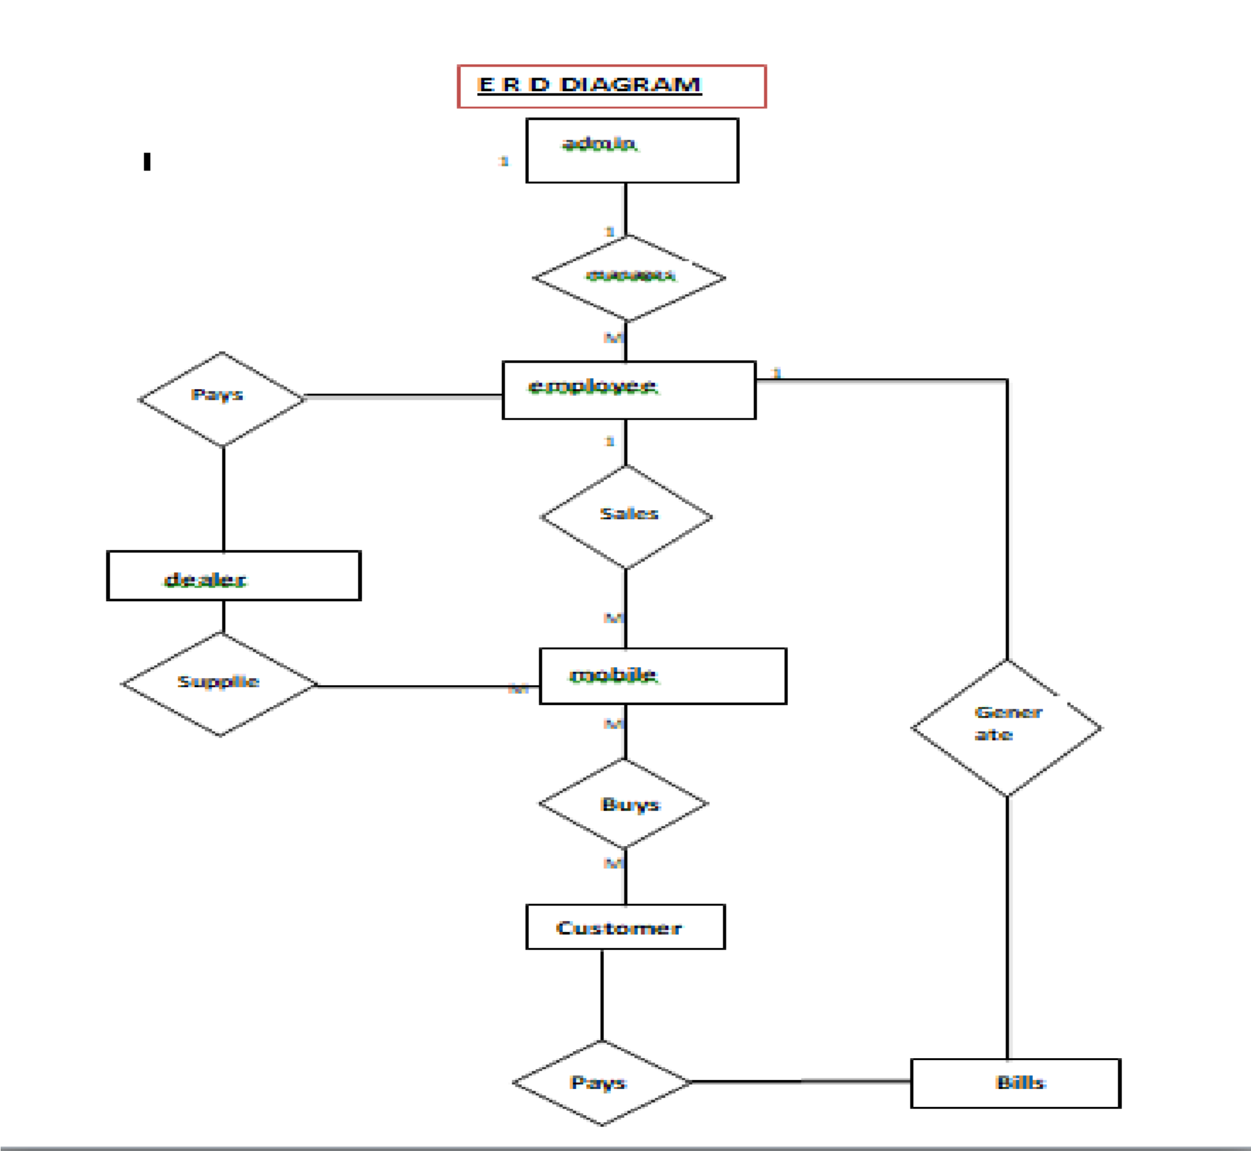

1



m

**Context level diagram First level DFD**

Customer

management

Suppliers

management

Sales management

Employee

management

Payment

management

Mobile

management

0.0

**Mobile Shop**

**Mnagement**

**System**

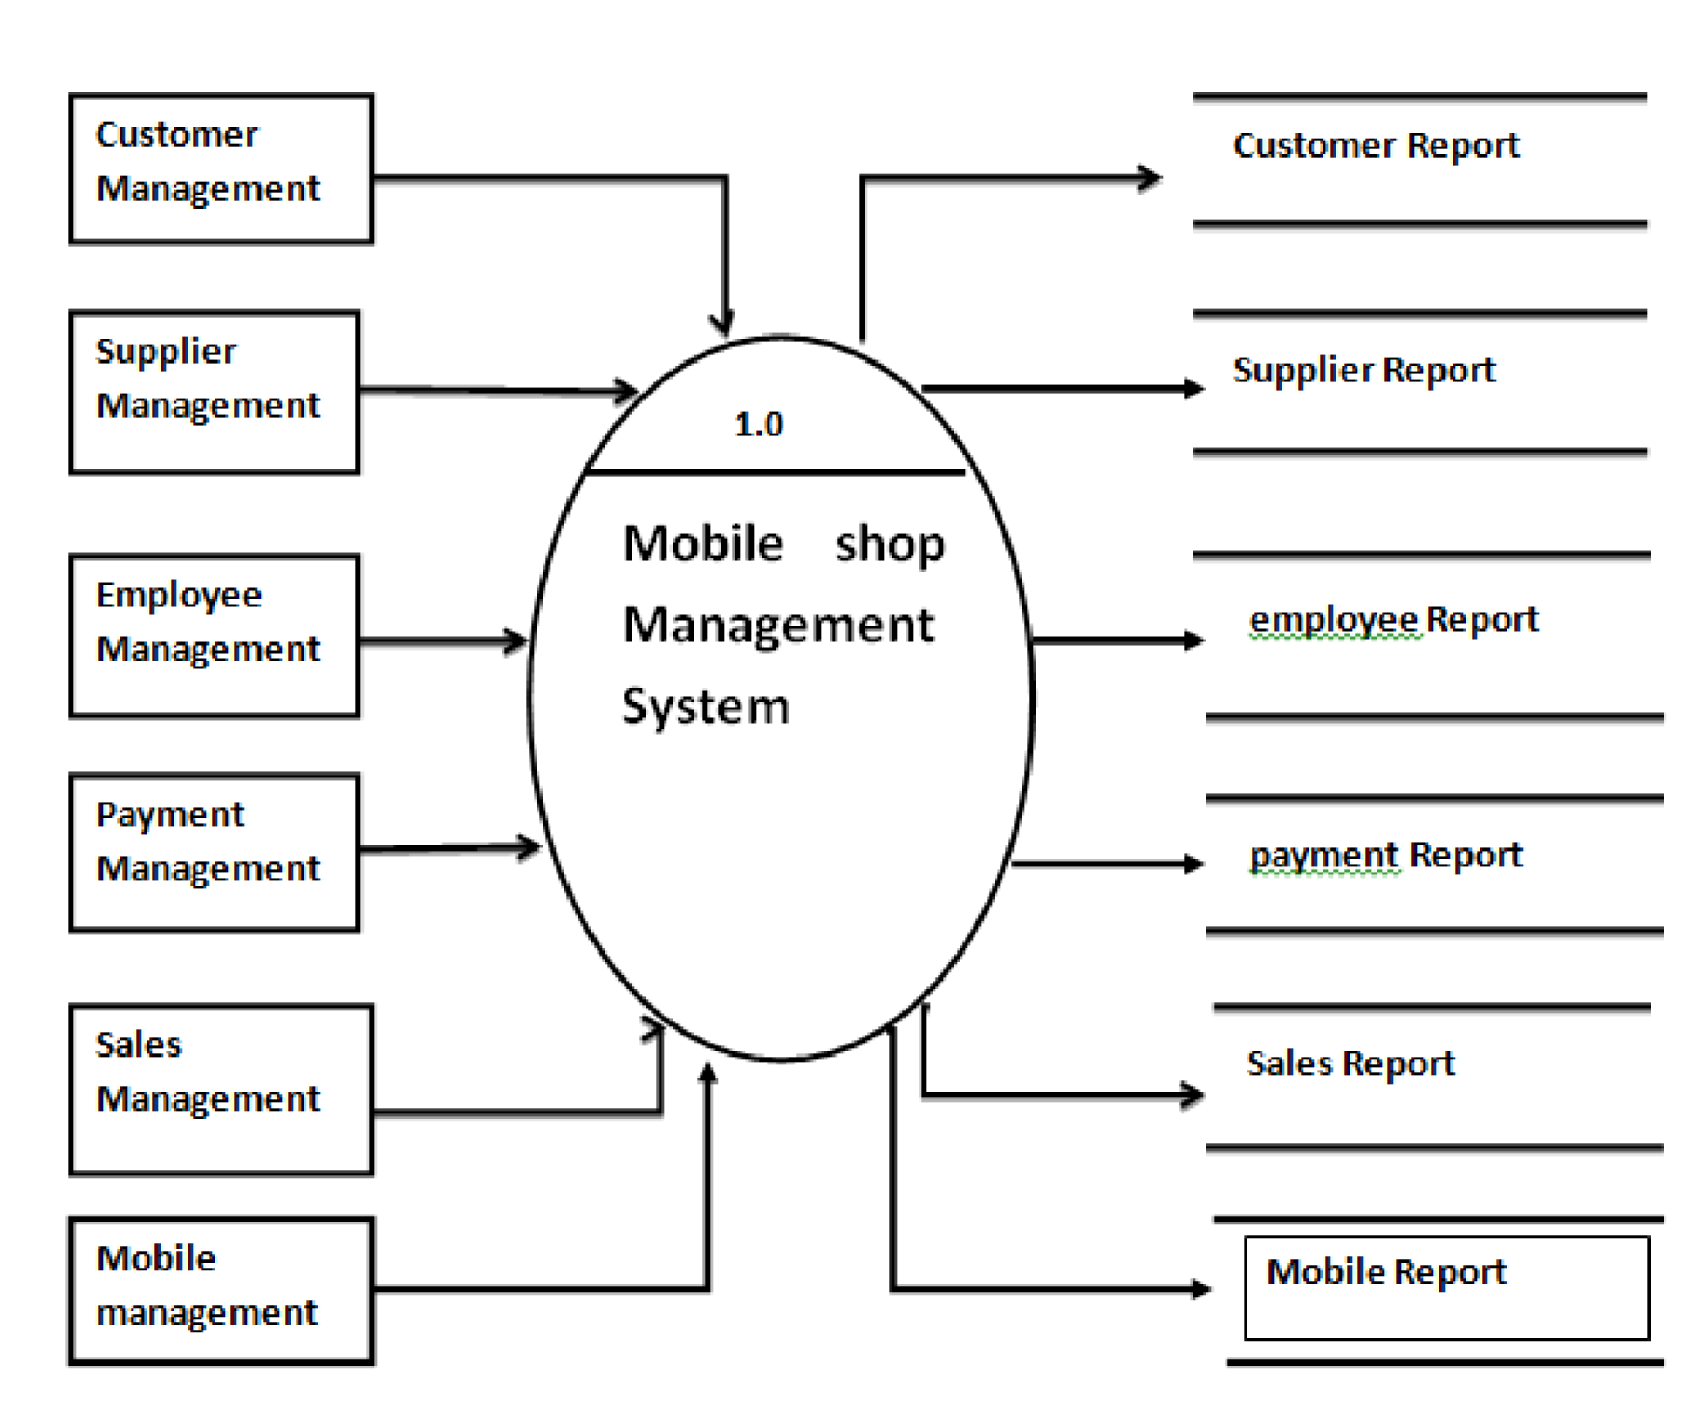

**Second level DFD**

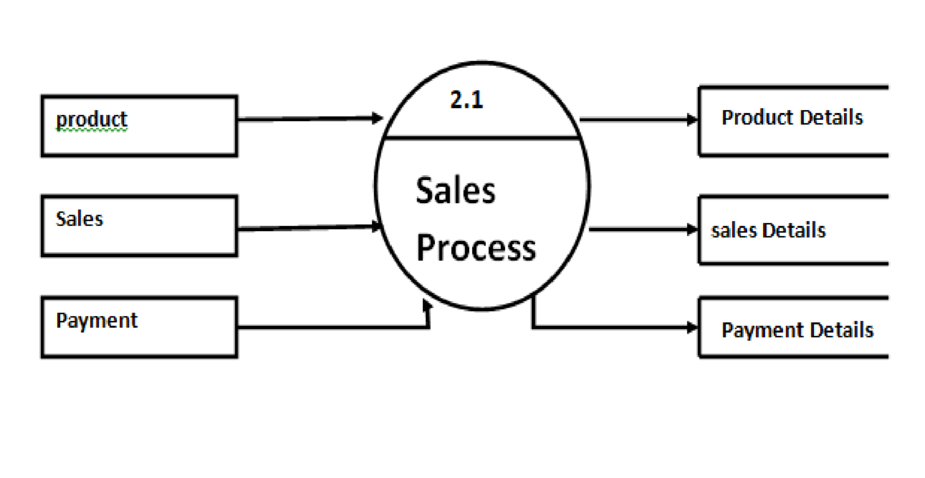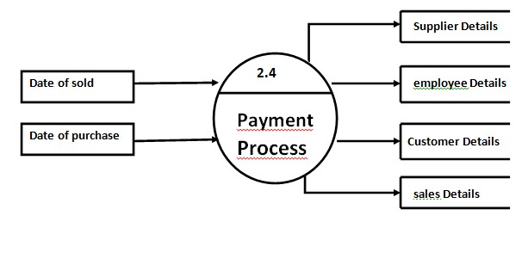

**2.2**

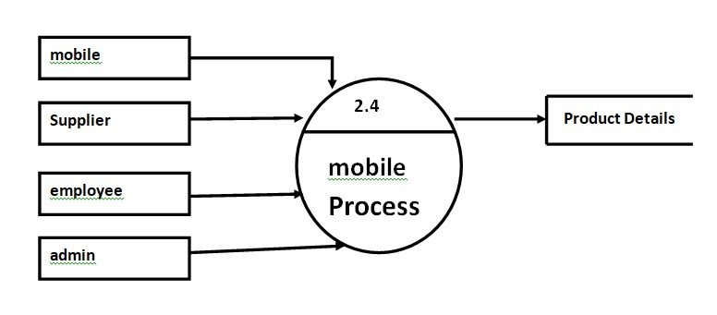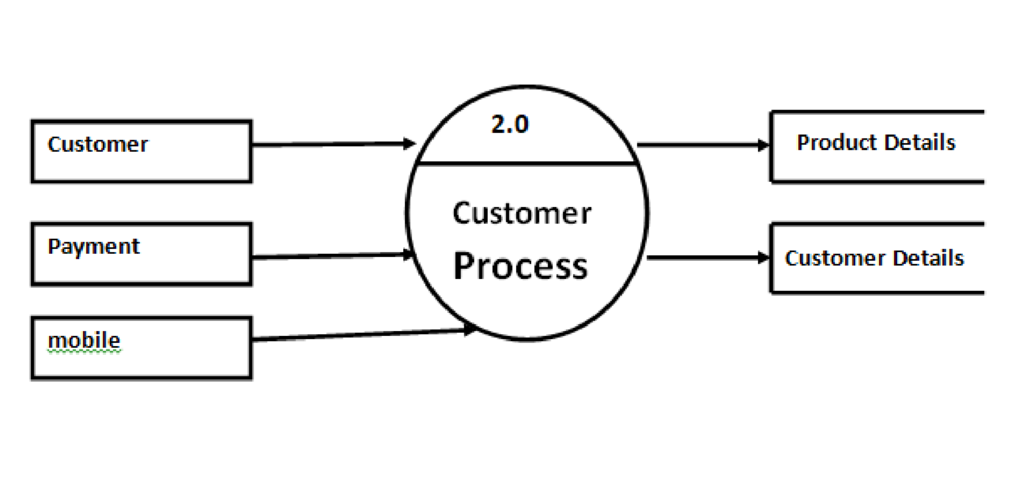

2.3

2.4

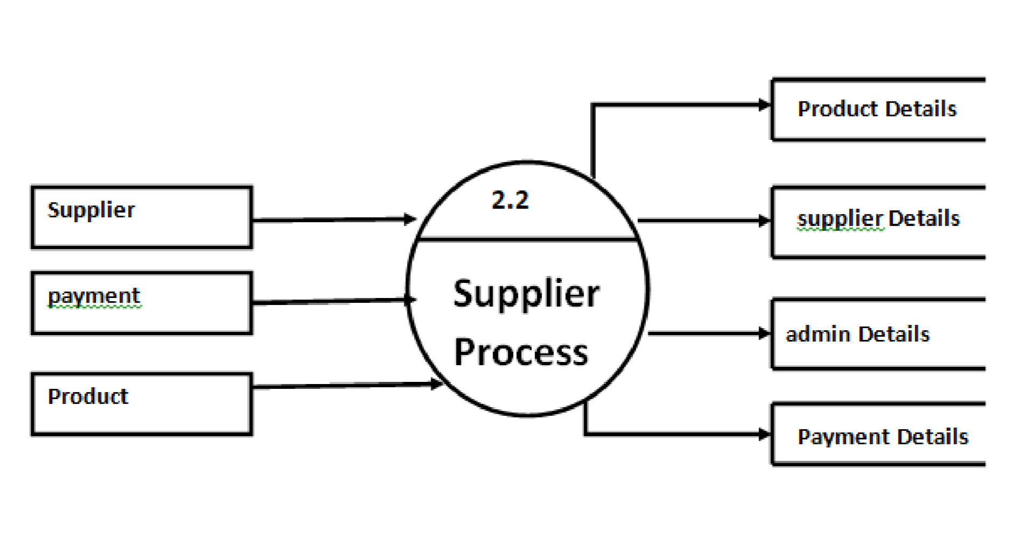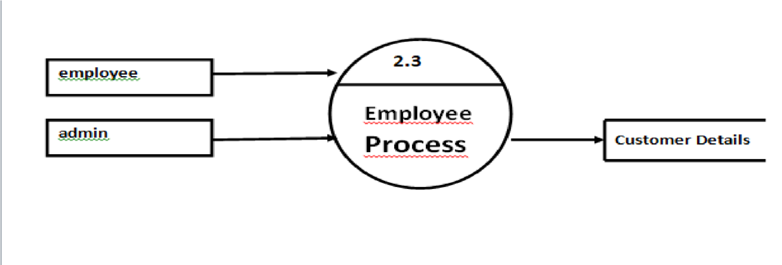

2.5

2.6

|  |
| --- |
|  |

Use case diagram

System

**arrenging moblie**

**selling moblie**

**generating reciept**

**select mobile**

**buy mobile**

**making payment**

**supply mobile**

**payment**

**employee**

**admin**

**customer**

**supplier**

Class diagram

**Customer**

+

cid: Number

+

cname: text

+

cadd: text

+

cph: Number

()

update

+

add

()

+

()

delete

+

view

+

()

**Supplier**

s_no: Number

+

s_name: text

+

s_add: text

+

s_phone: Number

+

+

add

()

+

update

()

()

delete

+

()

view

+

**Employee**

+

e_id: number

e_name: text

+

e_address: text

+

e_hours: number

+

+

e_phone: number

+

add

()

()

+

update

+

delete

()

+

view

()

**Bill**

b_no: number

+

+

c_no: number

P_name: text

+

+

total: number

+

add

()

+

update

()

+

()

delete

**Stock**

+

p_id: number

P_name: text

+

p_qty: number

+

()

add

+

+

update

()

+

delete

()

+

view

()

**Product**

p_id: number

+

+

p_name: text

p_info: text

+

+

mrp: number

+

add

()

+

update

()

+

delete

()

+

()

view

Activity diagram

moblie shop system

enter customer info

verify customer info

enter product info

give payment

generate bill

place order

request product for purchase

check availabilty

place purchase order

supplier

product

Sequence diagram

**/Customer**

**/Employee**

**/Generate Bill**

**/DataBase**

: Show product

()

1

()

: Select product

2

()

: Ask price and details

3

: Show details of product

4

()

5

: Finalize product

()

6

: Caluculate total amount

()

7

: Ask for payment

()

()

8

: Generate report

()

: Payment

9

: Amount pay details

10

()

11

: Give purchase product

()

12

: Give product Bill

()

13

: Update database transaction

()

14

()

: Database updated

**System Design**

**DATA DICTIONARY**

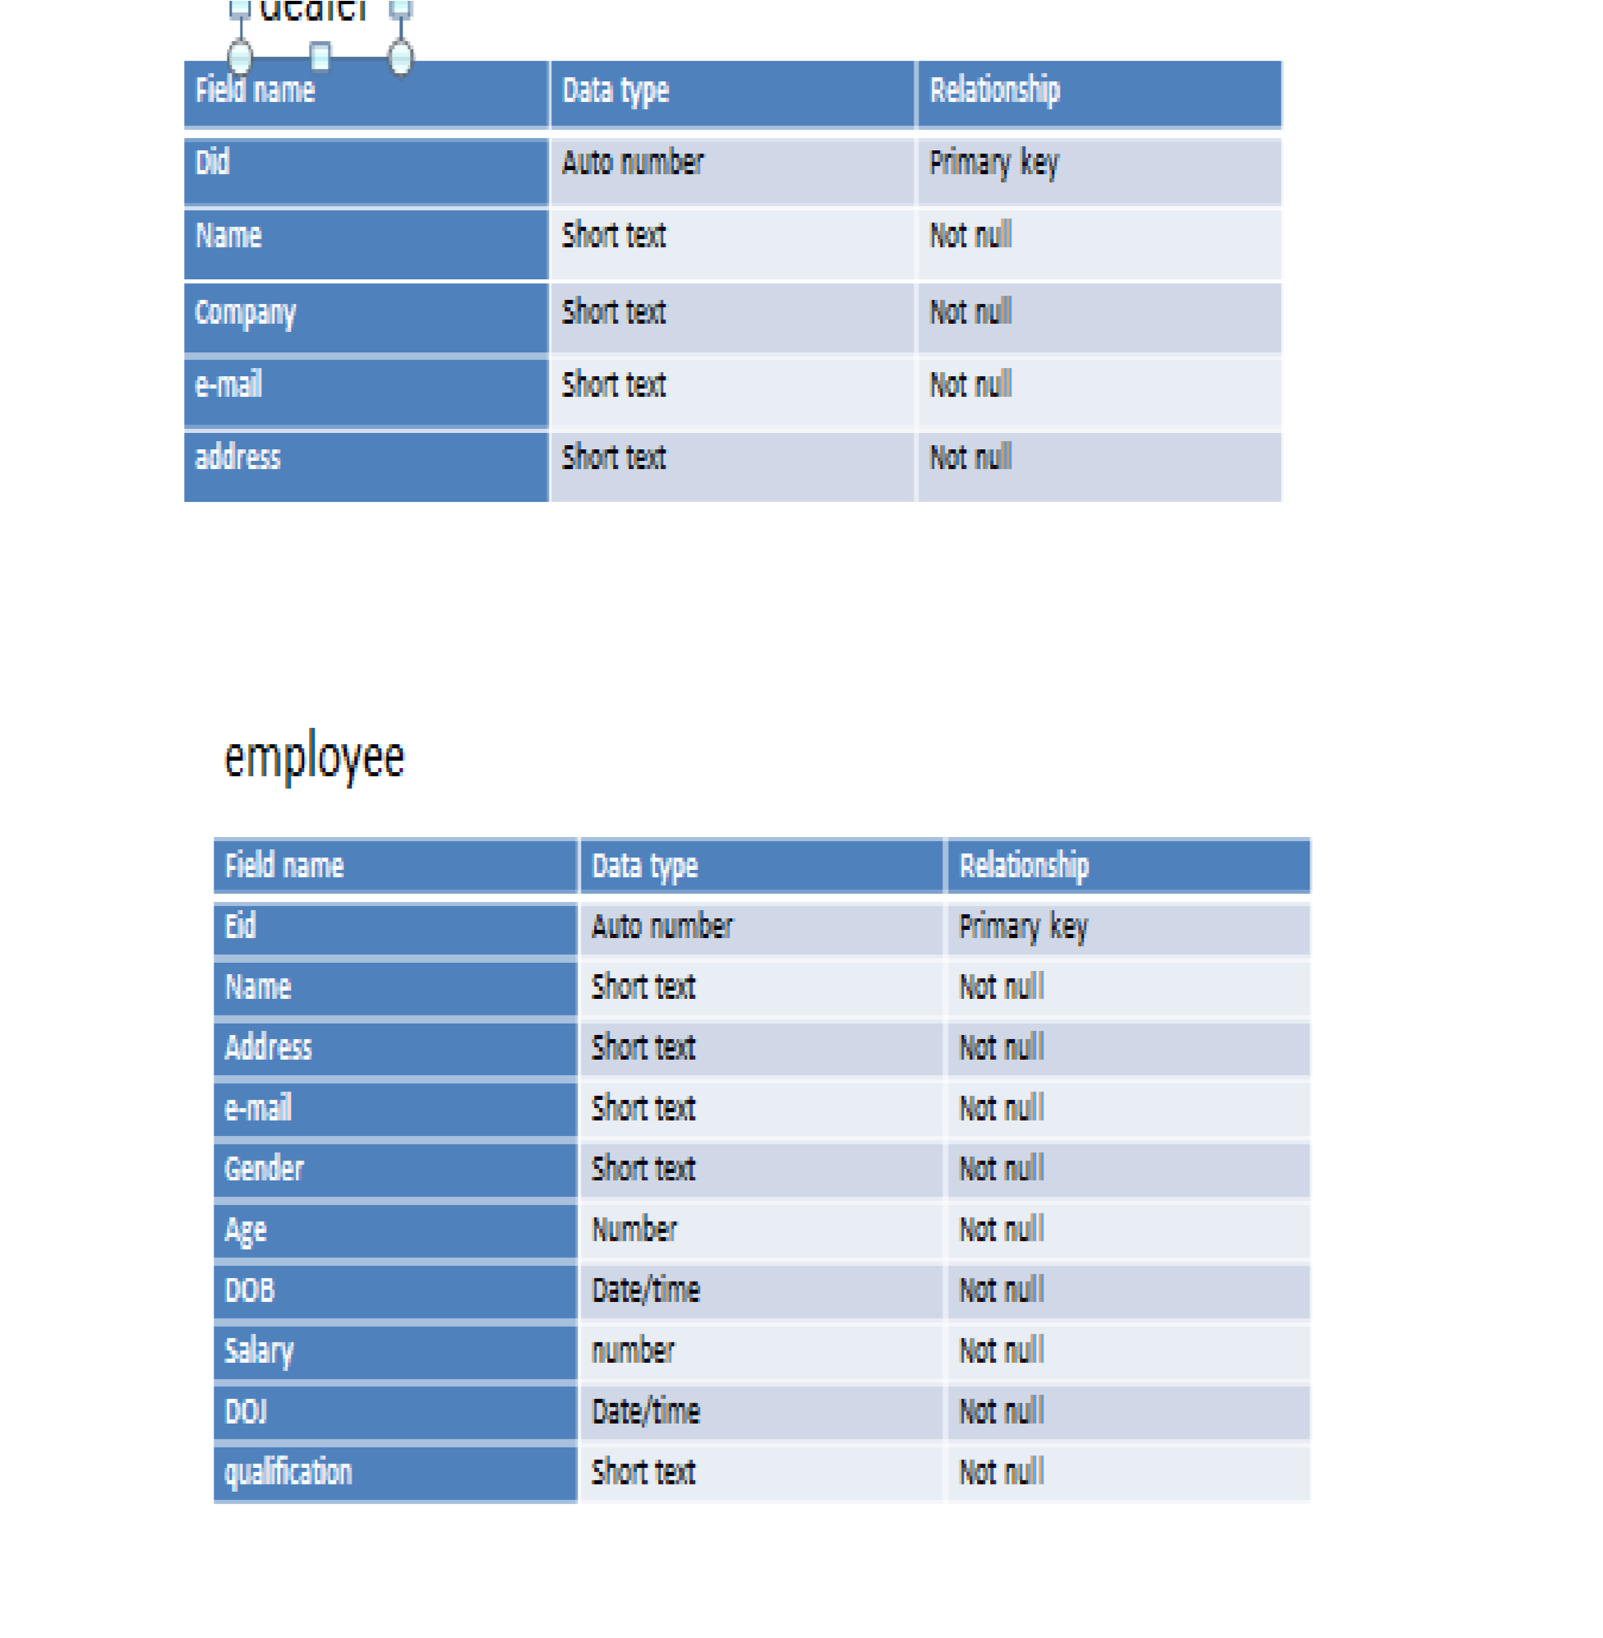

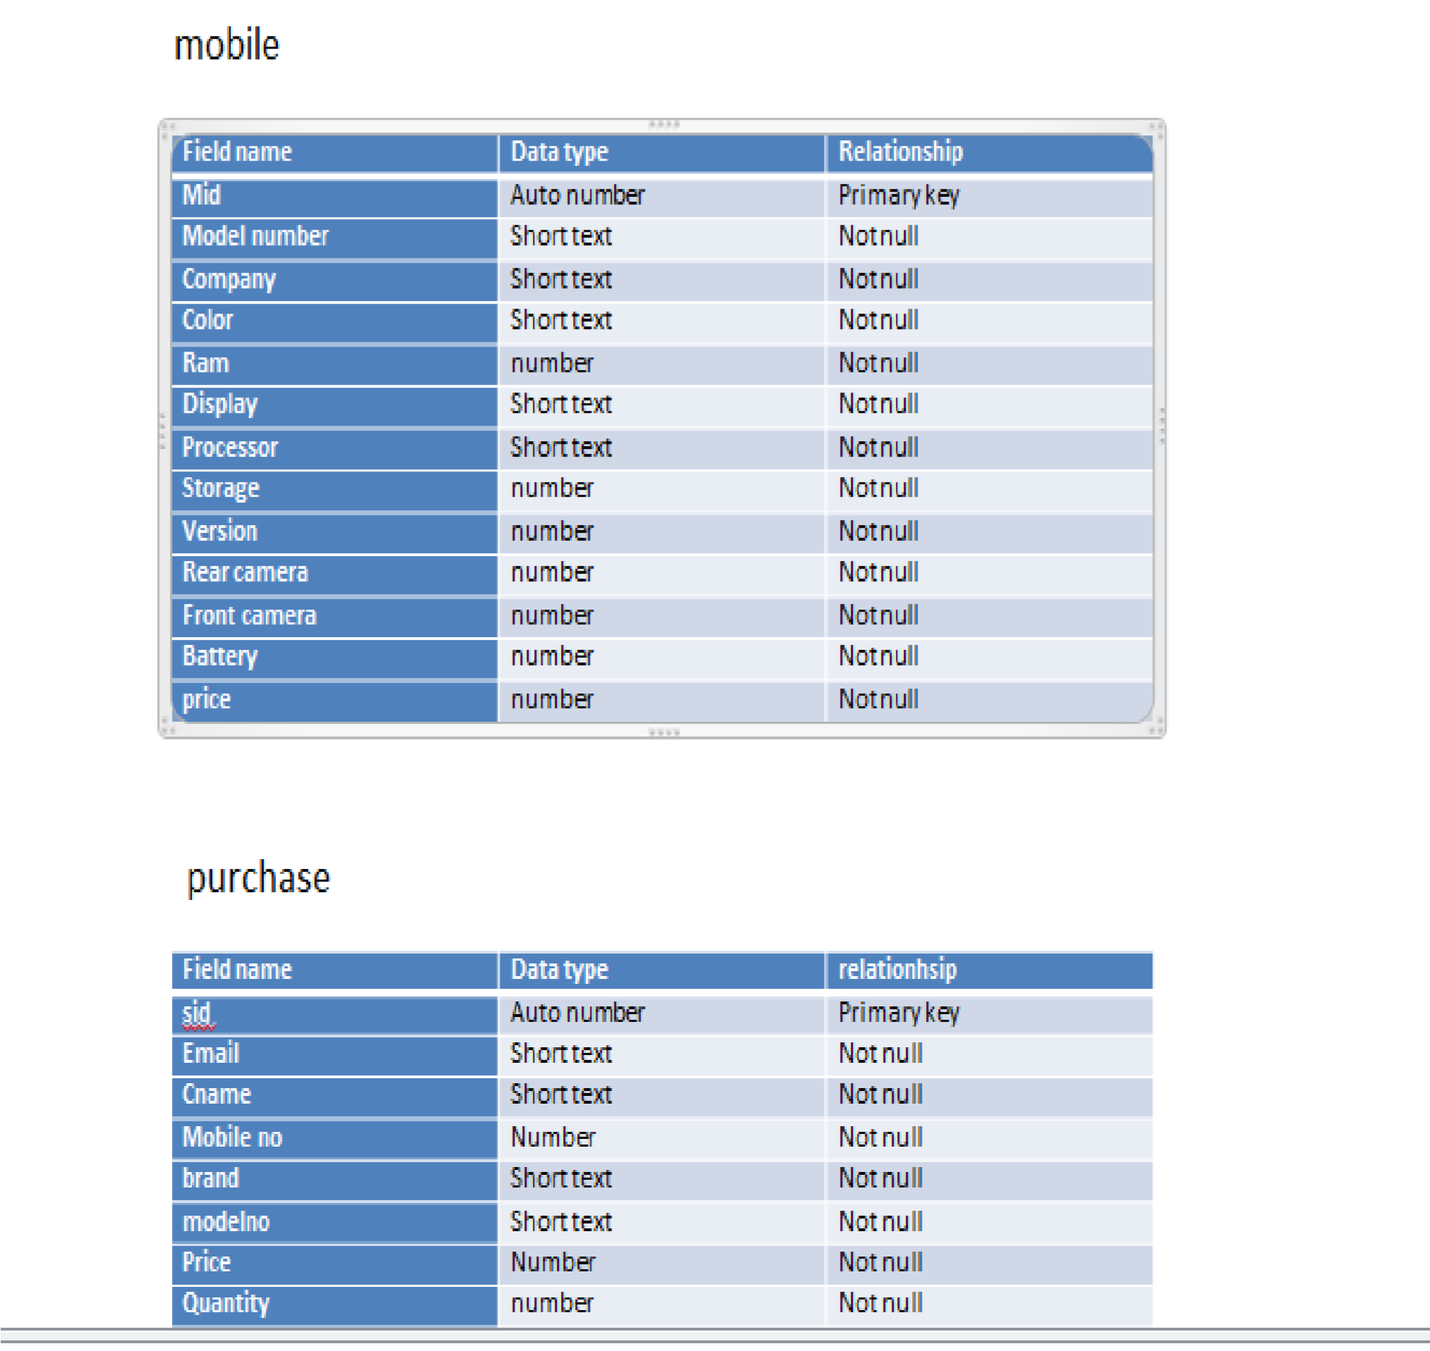

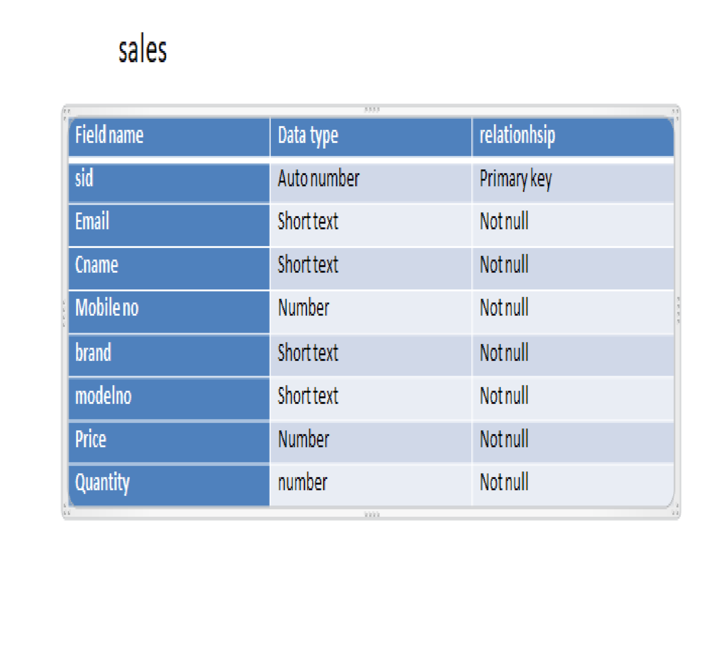

**FUTURE ENHANCEMENT**

1. Provide data recovery.

1. We will make this projects GUI based by using another programming language.

1. Provide more strict validation for number and alphabetic storage of data.

1. Making system robust to run effectively in large networking.

1. To provide the more security features to avoid unauthorized of software.

Bibliography

WEBSITE :-

We referred Google h for problem solving

[www.slideshare.com](http://www.slideshare.com/)  [www.google.com](http://www.google.com/)

[www.w3school.com](http://www.w3school.com/)

**THANK**

**YOU**